# **THE FLASH**

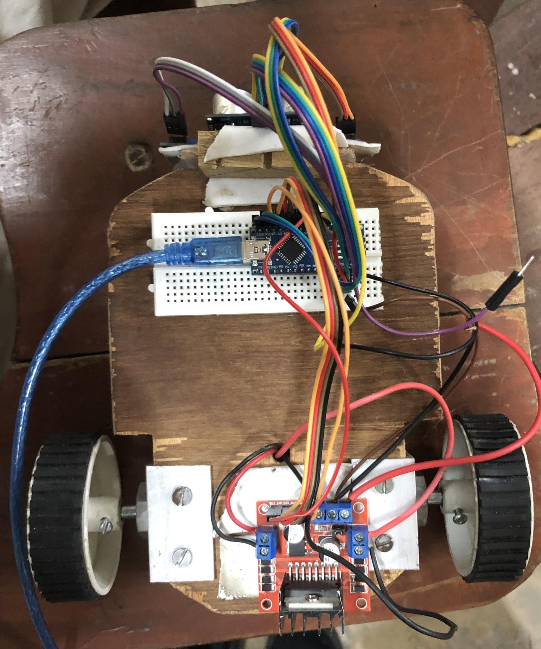

**Line Following Robot**

TEAM A6

DATE: 2023-06-27

BINOD POUDEL(MENTOR)

MEMBERS:

SRASHTA ADHIKARI

SHASHANK SINGH

RUDRANSH AGRAHARI

RANJIT DHAKAL

**INTRODUCTION:**

Line follower robot is autonomous that means it automatically follows a line which is pre-defined. It follows a black line on a white surface. Reading the pre-defined line by IR sensor array which is installed on the front-down side of the robot and sends those readings to the Arduino. The AT Mega microcontroller which is built in on Arduino analyzes those readings and does the particular operations. · The steering mechanism is simple in this robot. Three wheels are used, two wheels are on the back part connected with the motors and one independent wheel on the front- middle part of the robot. · On Straight line, the speed is fast and, on a turn, speed is relatively slow depending on turn angel. Good motor quality and good sensing quality will increase the robot movement performance.

**BACKGROUND:**

As technology becomes increasingly important in today’s world, it is invaluable to not only learn how to use technology, but also to understand how to create it. Since being engineer one should have sound knowledge of the other discipline. Most of the projects have limited scope to only specific discipline. This would limit one’s innovation and creativity. The project to make connection across several disciplines rather than learning topics in isolation as it combines mechanical, electronics, electrical, and programming skills.

It gives visual grasp of math and science.

It builds logical thinking.

It brings out innovation and creativity.

It enhances problem solving skills.

The robot designed in a such way that it not only tracked path and follows it but it also can detect the obstacle by the help of ultrasonic sensors.

**ROBOT STRUCTURE**

For making robot we were provided all the components from our leader. The components are:

> Chassis and body structure

> IR Sensors and Ultrasonic sensors

> Motor and Motor drive

> Caster wheel and driven wheel

>Arduino

**܀ Chassis and body structure:**

There are some good materials for designing robot such as wood, plastic, aluminum, etc. We must pay attention to the resistance, weight, and mechanical ability for choosing one of them.

In the designed robot, ply wood and aluminum have been used for chassis. And we have used ply wood for chassis because it's lightweight and strong enough for this project.

**IR Sensors and Ultrasonic sensors**:

Infrared sensors work on the principle of reflected light waves. Infrared light reflected from objects or sent from an infrared remote or beacon. Infrared sensors are also used to measure distance or proximity. The reflected light is detected and then an estimate of distance is calculated between sensor and object.

**Ultrasonic Sensor:**

Ultrasonic sensors work on the principle of reflected sound waves and are used to measure distance. One sensor can detect others operating nearby. Sound waves are emitted by the ultrasonic sensor and they're reflected back if there is an object in front of it. The sensor detects these waves and measures the time it takes between transmitting and receiving those sound waves. Distance is then estimated by the time interval between sensor and object.

**Motor and Motor Driver:**

An electrical motor is a rotating device which is made to convert electrical energy into mechanical energy. We use motor in many devices such as mixers, computer, robot, etc. Motor driver is a device which act as an interface between the motors and the control circuits. Motor requires high amount of current whereas the controller

circuit works on low current signal. So, the function of motor driver is to take a low-current control signal and then turn it into a higher-current signal that can drive a motor

**Caster and Driven Wheel:**

A caster is an undriven wheel that is designed to be attached to the bottom of an object to enable that to be moved. Casters are used in numerous applications, including shopping carts, office chair, robot, etc.

A driven wheel is a wheel of a motor vehicles that transmits force, transforming torque into the tractive force the tires to the road, causing the vehicle to move. The powertrain delivers enough torque to the wheel to overcome stationary forces, resulting in the vehicles moving forwards and backwards.

**Arduino**

Arduino is an open-source electronics platform based on easy-to-use hardware and software. Arduino boards are able to read inputs - light on a sensor, a finger on a button, or a Twitter message - and turn it into an output - - activating a motor, turning on an LED, publishing something online. You can tell your board what to do

by sending a set of instructions to the microcontroller on the board. To do so you use the Arduino programming language (based on wiring), and the Arduino Software based on Processing.

**ARDUINO NANO:**

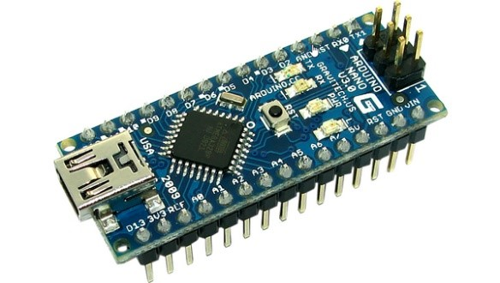

**ULTRASONIC SENSOR**

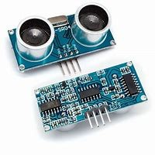

**IR SENSOR**

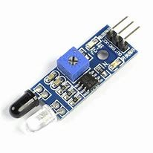

**MOTOR:**

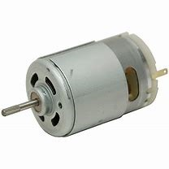

**MOTOR DRIVER:**

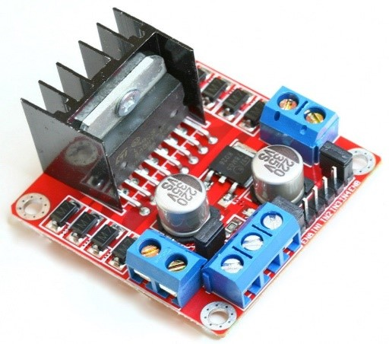

**WHEEL:**

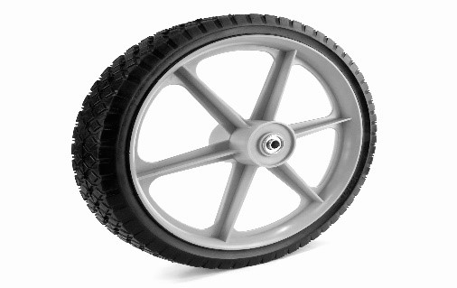

**CASTOR WHEEL:**

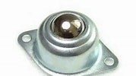

**Bread board:**

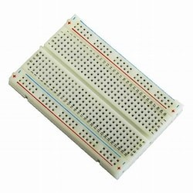

**BATTERY:**

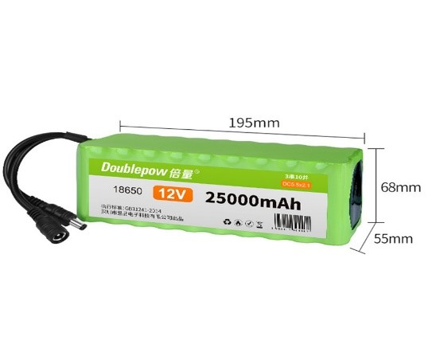

**JUMPER WIRE:**

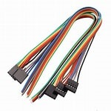

**CHASSIS (PLY WOOD):**

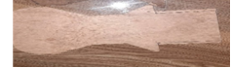

**WORKING PRINCIPLE:**

* The robot must be capable of following a line.
* It should be capable of taking various degrees of turns.
* The robot must be insensitive to environmental factors such as lighting and noise.
* It must allow calibration of the line’s darkness threshold.
* Scalability must be a primary concern in the design.

**SCHEMATIC DIAGRAM:**

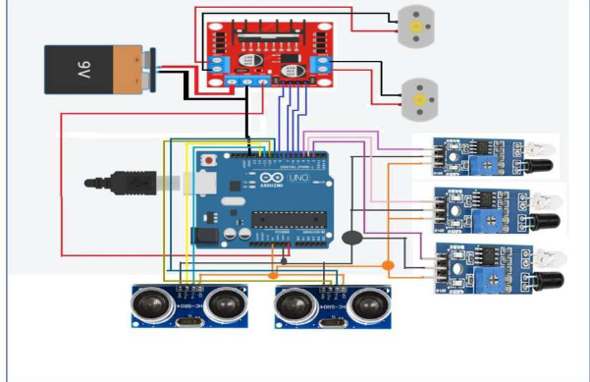

**WORKING PRINCIPLE:**

12 V supply (Battery) is passed to DC Motor Control. Motor control runs properly in 12 V supply. It has a pin which provides 5V supply by converting from 12V. Arduino, both motors including 3IR and 1 US sensors work on 5V. Arduino and Motors get supply directly from DC Control while Sensors get through Arduino.

* We should use the property of light to detect any line, because reflection of light on white surface is maximum and minimum on the black surface.
* The robot uses IR (infrared circuit) sensors to sense the line.
* Output of the sensors is an analog signal which depends on the amount of light reflected back.
* In IR sensor the transmitter which is basically IR LED emits the infrared light on the object.
* The light emitted by the transmitter hitting on the black surface get absorbed thus giving a low output.
* The light emitted by the transmitter hitting on the white surface get reflected more and gives high output.
* Using above steps, we can control the movement of the robot by driving the wheels attached to the motor are controlled by microcontroller.

**Condition for Turning of bot.**

#When a sensor is on the black line it reads 1 and when it is on bright it reads 0.

# When right sensor or middle and right sensor comes in white region, then right motor stops while left motor continues to move so that right turn takes place and robot returns on white line.

# When left sensor or middle and right sensor comes in white region, then left motor stops while right motor continues to move so that left turn takes place and robot returns on white line.  
#If all the three sensors will be on white surfaced then they all will be high and no line is detected, robot moves in a circular motion until line is found.  
  
# If all the three sensors will be on black US Sensor, distance is calculated and direction is subjected surfaced then the condition goes to US sensor

**ANALYSIS**

**STRENGTH**

The team successfully built-up line and path following robot. Dimensioning and fabrications were done as per the rule specifications. Robot specification was also ensured. The chassis had ground clearance of 20 mm.

**CHALLENGES**

The main challenge while making this robot was ensuring efficiency. Also, choice of line was made in the hardware abstraction and couldn't be changed by the software. Sensor position on robot and distance between sensors was another issue to consider. If the sensor position isn't effective, the robot may run out of track and the robot may not be reliable

**OUTCOME**

The team successfully built an anonymous line and path following robot. The project challenged the team to co-operate, communicate

for sharp turns. And expand understanding of electronics, mechanical systems and their integration with programming which makes connections across several disciplines rather than learning topics in isolation. The successful completion of every task demonstrated the potential of mechatronic system and a positive group dynamic.

**CONCLUSION AND RECOMMENDATION**

Technology becomes increasingly important in today's world, it is invaluable to not only learn how to use technology, but also to understand how to create it. Though the use of line and path follower robot is very common today, selection of optimal sensors to achieve a high efficiency is still a great challenge. Our robot was successfully able to follow the sample path which proves the effectiveness in our proposed method. The robot still has a few shortcomings but achieves as most of the objectives